

Part 4

A night flight to Seattle…

Microsoft

(Day 6)

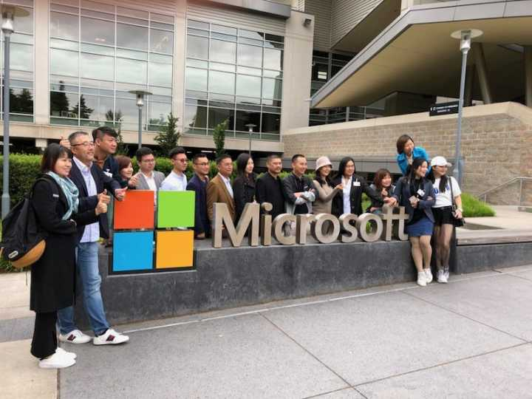

(Unfortunately, I lost many of my notes taken at Microsoft, so in the following, I just list some key points with the picture demonstration.)

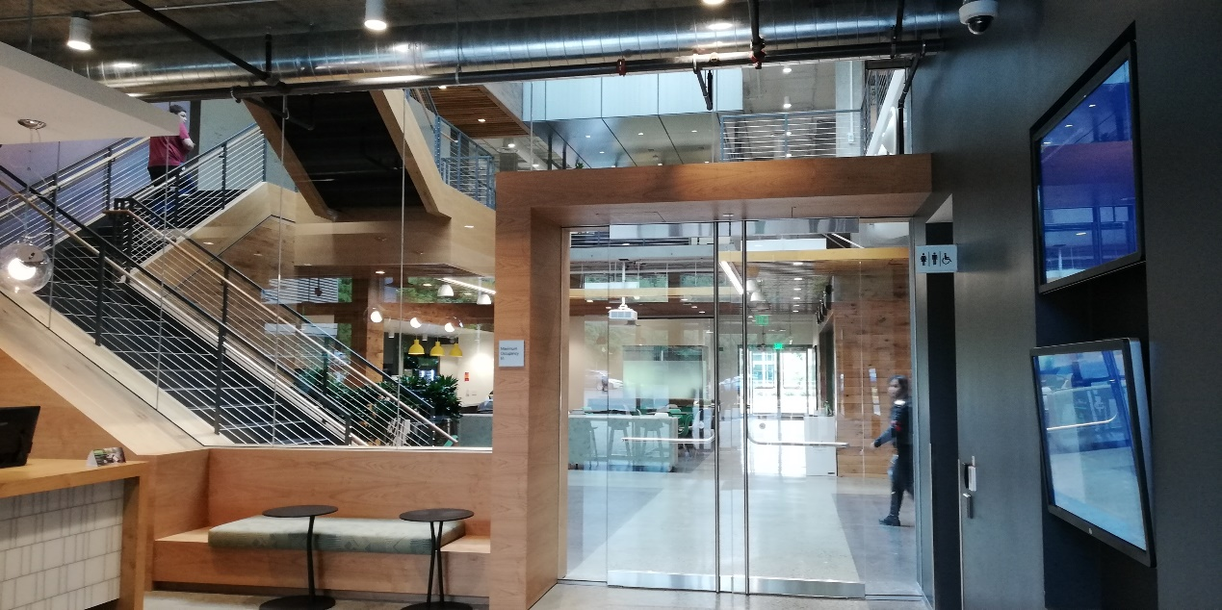

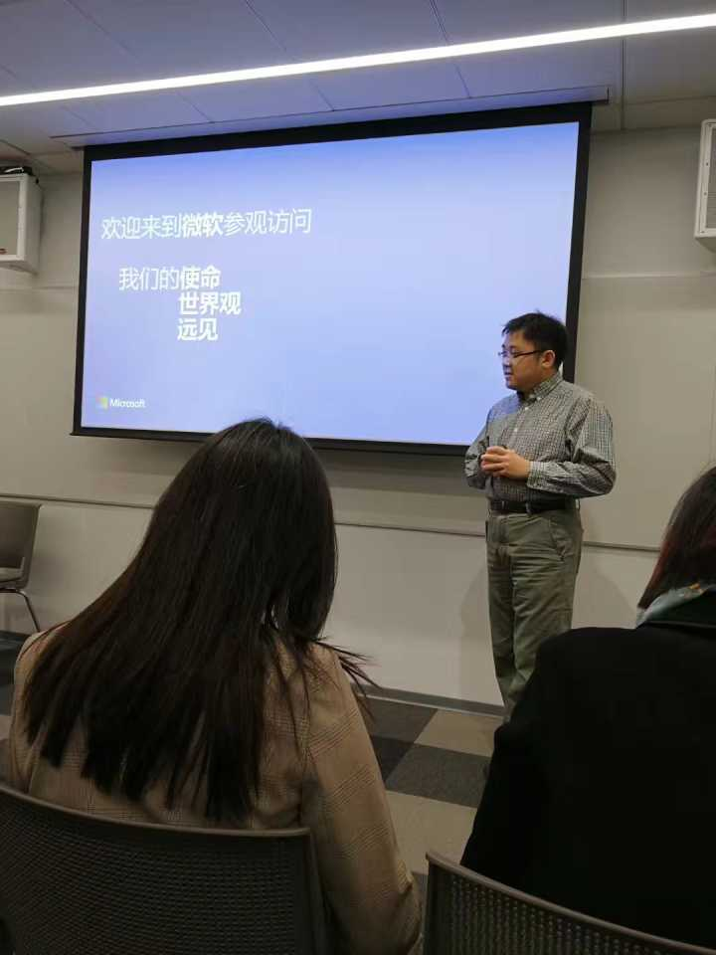

Welcome to Microsoft

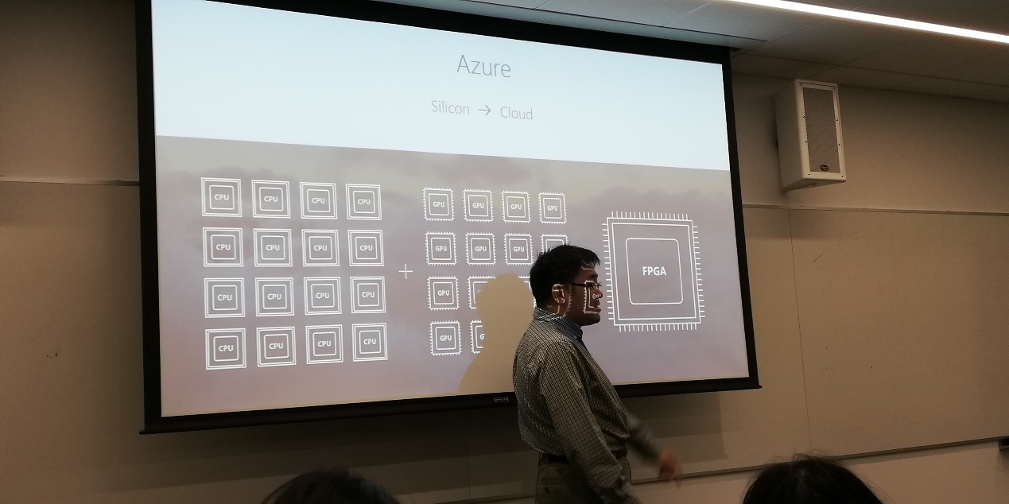

Our Mission

Enable every person and organization to achieve more with the magic of software

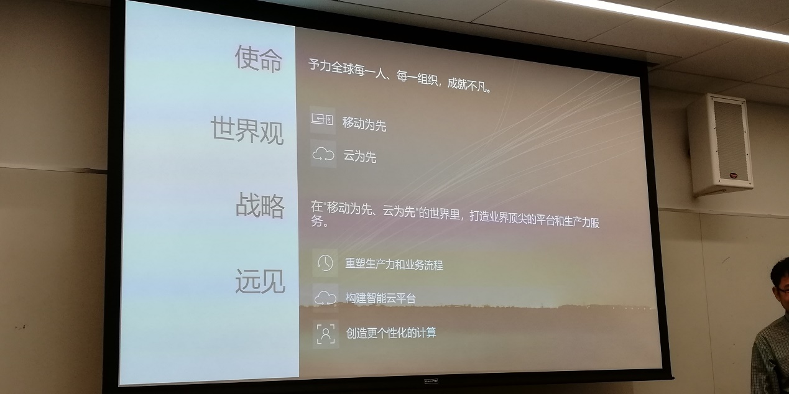

Create personalized computing system

Build smart cloud-based platform

Reforge productivity and business process

In the “Mobile first & Cloud first” world, we try to build the world-class platform and manufacturing services.

Cloud first

Mobile first

Our vision

Our strategy

Our worldview

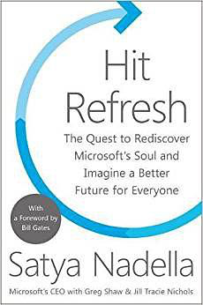

Notes taken from the book *Hit Refresh by* Satya Nadella

* Our industry doesn’t respect tradition. What we respect is innovation.
* Microsoft is based on a belief in the magic of software. The magic of what we can do with people at work and at home with our software.
* As workers at Microsoft, we should ask ourselves: What is the company about? Why do we exist? What makes us unique? How different the world would be without us?

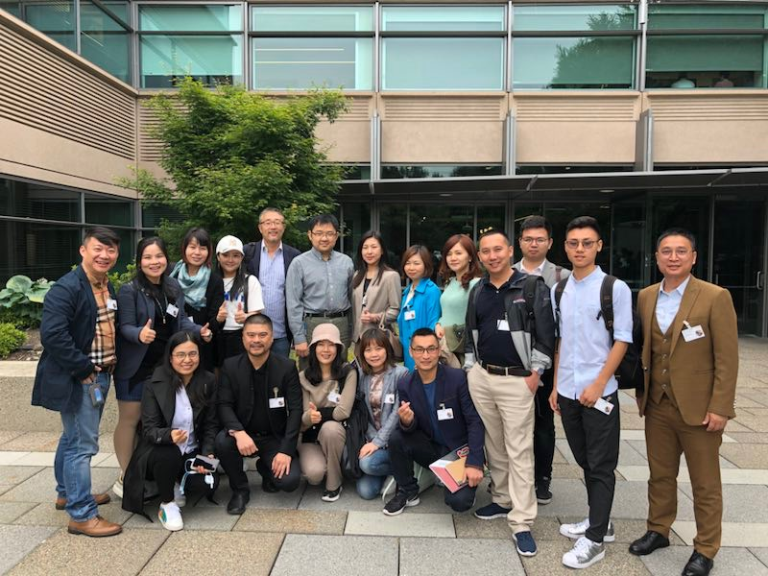Visiting Amazon’s new headquarter in downtown Seattle

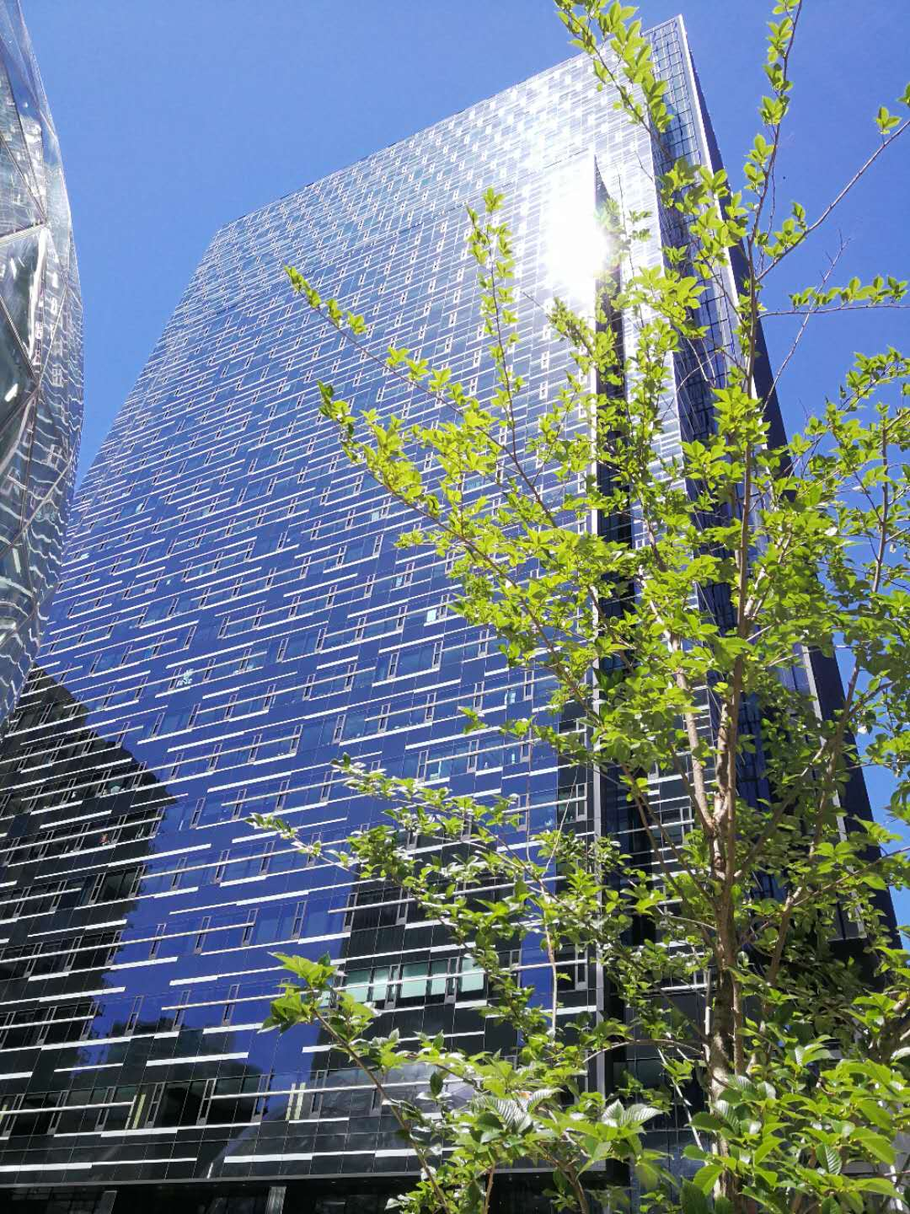

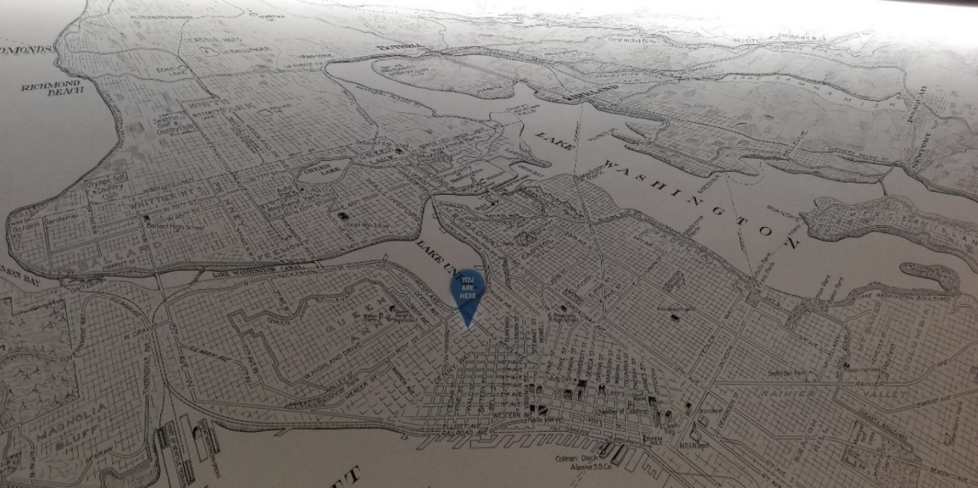

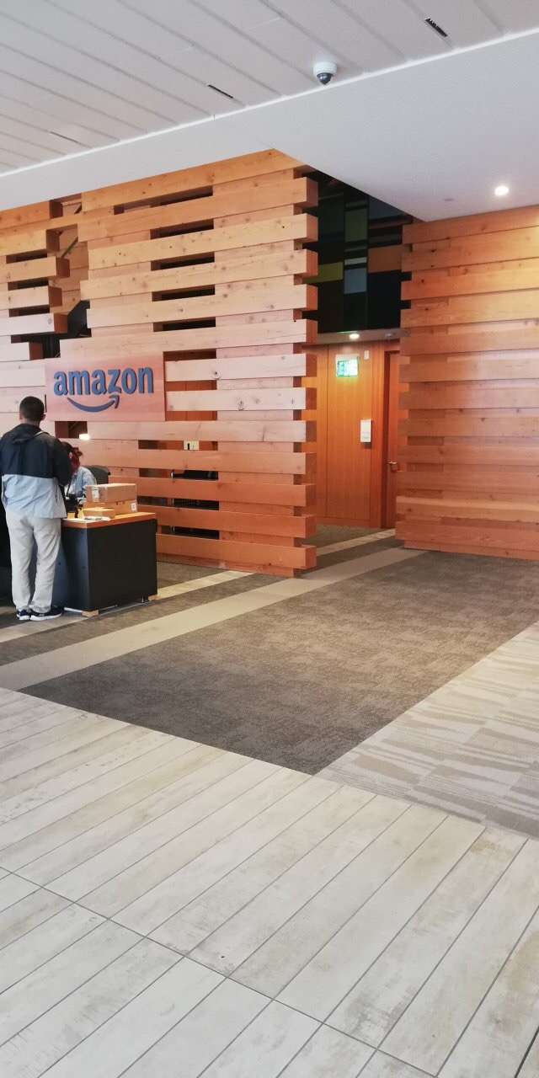 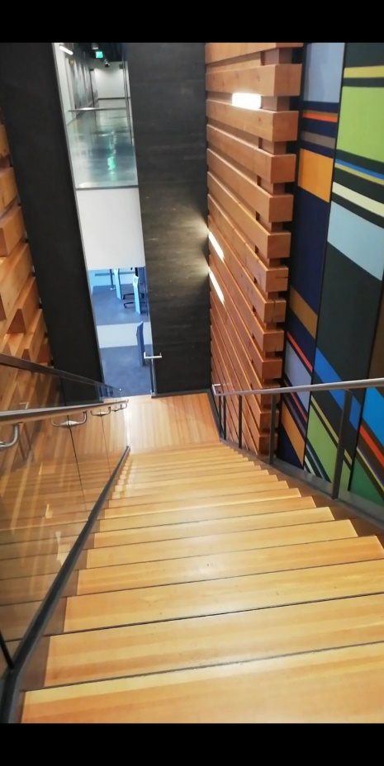

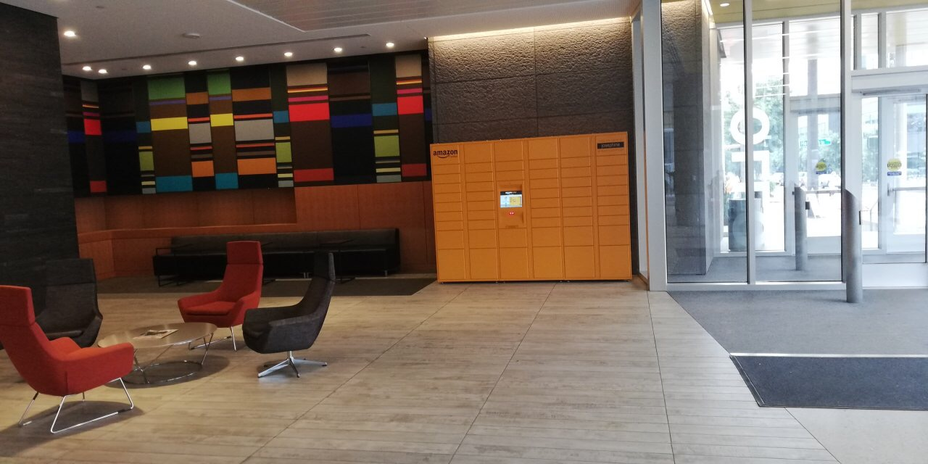

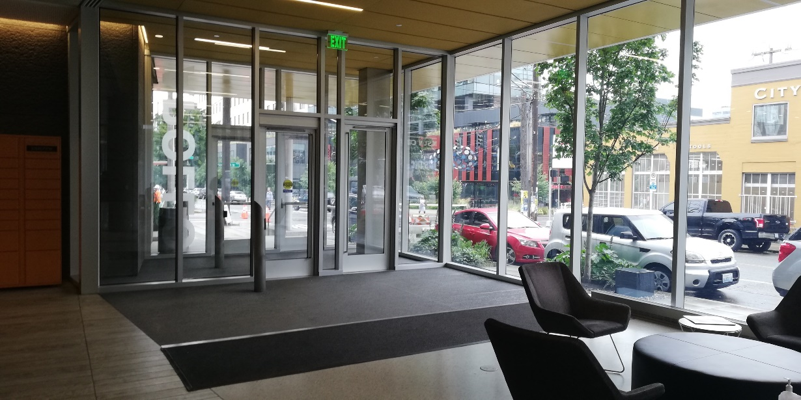

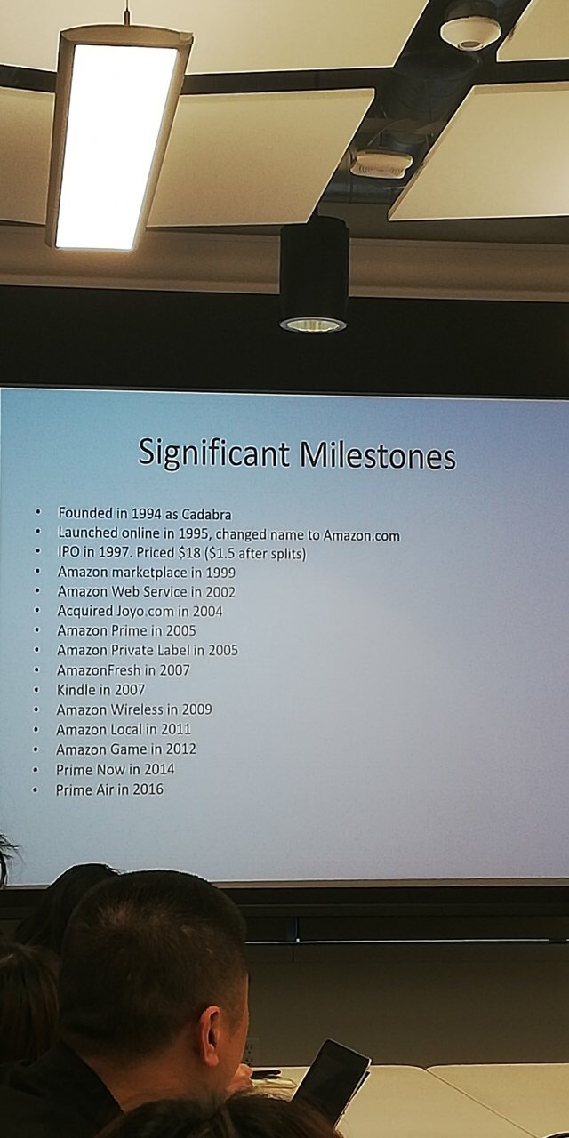

* A tough beginning

When Amazon was first founded, there were only four people working at the company and their garage was the office. Due to there wasn’t enough electricity power supplied to keep the computer servers running, they had to string these thin, orange, electric extension cables from every room in the house to get enough power into the room where the office was. They couldn’t even plug a vacuum cleaner in the house, so they realized that we needed to move to a new office.

* A mistake

“when we launched the store, we made a very early mistake, a software bug: we found that customers could order negative quantity of books and we’d credit their credit card with the prices of the books. We fixed that one later. We made a bunch of mistakes all the time, my whole body is covered in scar tissue. we learnt some things from those mistakes.” – Jeff Bezos

* Lessons (from *Amazon progression history video* by Jeff Bezos )

1. Be obsessed with customers.

We have been doing this from the very beginning and it’s the only reason that Amazon.com exist today in any form. We always serve customers first. If we are given the choice between being obsessed with competitors and being obsessed with customers, we’ll always choose to be obsessed with customers. We pay attention to what our competitors do, but it’s not where we get our motivation from. We really like to start with customers and work backwards. So, again, if you’re truly obsessed with customers, it’ll cover a lot of errors.”

1. It’s really important to invent

“Any time we have a problem, we never accept hoping or thinking, we try to figure out a solution that gets both things and that often requires invention. We are talking about inventing on behalf of customers. It’s not customer’s job to invent for themselves. You need to listen to customers. it’s critical, but they won’t tell you everything and you really need to empathize with them, notice things that they may have ignored and see them as opportunities for innovation.” (This corresponds to human-center concept in *Strategic Innovation & Design Thinking.*)

1. Think long term

“Any company that wants to invent on behalf of customers has to think long term. I find most of the initiatives that we undertake may take five to seven years before they pay any dividends for the company. They may start to pay dividends for customers right away, it often takes a long time to pin out the shareholders of the company. So, the ability to think five-or-seven-year timeframe is really critical. It allows the willingness to be misunderstood. Many of the inventions that we undertake may get disrupted in any way and may be misunderstood in the early beginning. Thus, it’s important for us to think long term so we can tolerate being misunderstood. We’ve been called Amazon. Toast, Amazon. Cum and many other bad names. If we think we are right, then we continue; if we think we are wrong and being criticized, we change and fix it. It’s a huge competitive advantage to be able to think long term.”

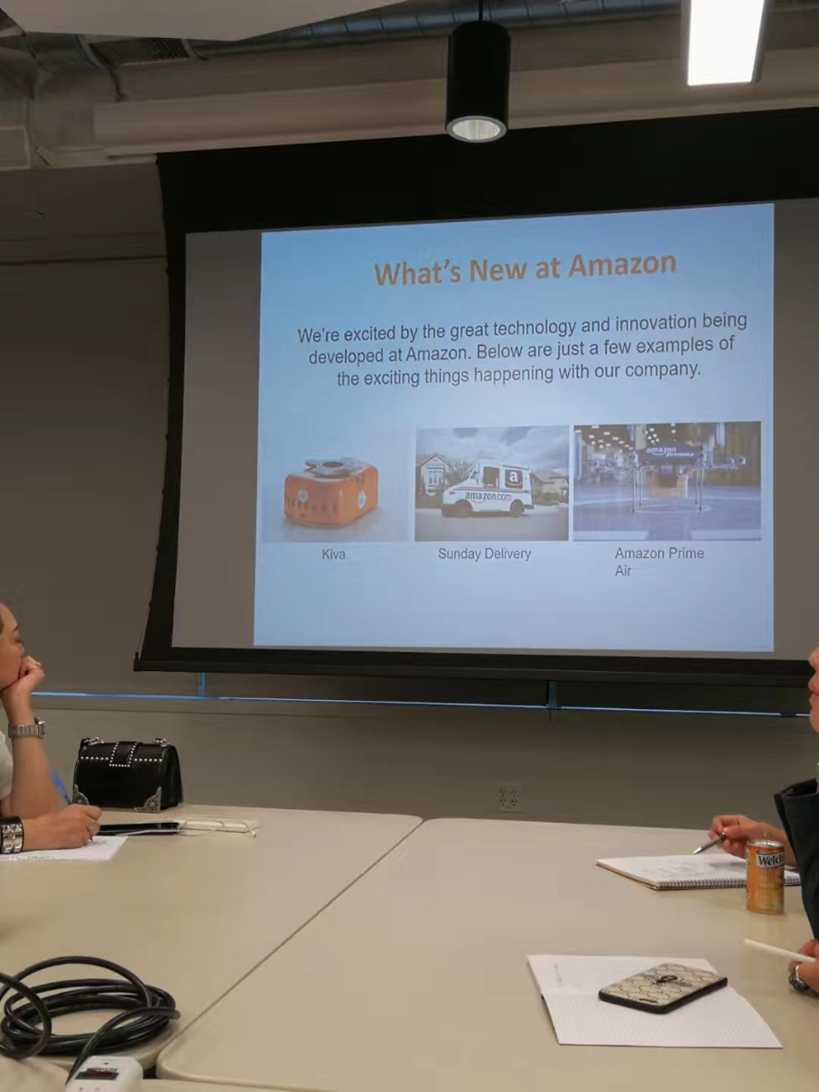

Amazon’s spectacular glass domes – a living building!

